Nanjing University of Posts and Telecommunications


Course: Coding Theory and Application of Chinese Character
School：计算机学院、软件学院、网络空间安全学院

Student No: F1225040117
Name: MD ZUNAID TAUSIF
Submission date: 2025-12-26
Lecturer: Fei Wu / Shangdong Liu
Major: MCT

Course Goals / Evaluation Criteria | Grade
Course Goal 1： Understanding the development history of computer Chinese character coding and understanding the difficulties of computer Chinese character coding; understanding the problems that pinyin faces when foreigners learn Chinese. (20 Points) | 16
Course Goal 2： Master the concept of Chinese character components, master the concept of Chinese radicals and its meaning in Chinese character formation. (20 Points) | 16
Course Goal 3：To understand the relationship between the stroke and the root of the radical. The general differences and special cases in the number of strokes (single strokes), know how to count the number of strokes of more than 200 commonly used Chinese radicals, and understand the subtle differences between strokes and composite strokes. (20 Points) | 16
Course Goal 4：Design a Chinese input method and provide the flowcharts. (20 Points) | 16
Course Goal 5：Implement a Chinese input method software. (20 Points) | 16
Totally | 80
Comments:
Md Zunaid Tausif performed well in the course, showing a good understanding of the development of computer Chinese character coding, as well as strong knowledge of character components, radicals, and glyph structures. His expression and word-processing skills were also noteworthy. Although there is still room for improvement, his overall performance was solid and shows strong potential for growth.

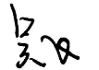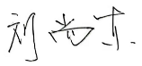
2025-12-26

Abstract
This project presents the implementation of a Chinese input method system based on Easy Chinese Code (ECC). The ECCApp is designed using Python with Tkinter for GUI development and pandas for data handling. The system uses a dataset (data.csv) that includes Chinese characters, their voice codes, and three ECC components. By typing the ECC sequence, users can retrieve and display corresponding Chinese characters. The program supports both exact matching and live prefix suggestions, making it simple yet efficient for users learning or testing ECC encoding logic.

1. Chinese Character Coding
The concept of Chinese character encoding refers to how characters are digitally transformed into computer-readable codes for use in text processing, data exchange, and storage. Because the Chinese writing system contains thousands of characters with intricate forms, an efficient and consistent coding system became essential for the age of digital communication. Encoding ensures that every character has a unique digital identity, allowing it to be stored and transmitted across different platforms without confusion.
Historically, before electronic encoding standards, communication used early systems such as telegraph codes, which represented characters using numeric sequences. Another early example was the Four-Corner Method, which identified a character by the shapes at its four corners—a clever yet manual way to categorize characters before computers existed. These early innovations gradually shaped the foundation of modern Chinese character encoding.
The development of modern coding standards began in the late 20th century, and the process can be summarized through several key milestones:
- 1980 – GB2312-80: The first official encoding standard for Simplified Chinese, containing 6,763 characters and 682 symbols. It used a two-byte structure compatible with ASCII, setting the base for future standards.
- 1984 – Big5: Introduced in Taiwan and Hong Kong for Traditional Chinese characters, Big5 supported 13,053 characters. Its format was similar to GB2312 but served users of Traditional script.
- 1991 – Unicode: The introduction of Unicode marked a global revolution in digital text processing. It unified writing systems worldwide, integrating both Simplified and Traditional Chinese into a single standard. Unicode supports multiple encoding formats such as UTF-8, UTF-16, and UTF-32.
- 1993 – GBK (Guobiao Kuozhan): A major expansion of GB2312, adding around 21,000 characters while keeping backward compatibility. It enabled display and input of many rarely used and traditional characters.
- 2000–2005 – GB18030: China’s most comprehensive and mandatory standard, covering more than 70,000 characters. It uses a flexible multi-byte structure similar to UTF-8 and ensures compatibility with Unicode, including minority and regional scripts.

Currently, Unicode serves as the global standard for all digital systems, while GB18030 remains the official Chinese national encoding standard. Together they form the backbone of digital communication in Chinese computing environments. The modernization of Chinese encoding not only improved information efficiency but also supported technological innovation, economic growth, and cross-lingual communication.
By simplifying character input and recognition, encoding systems make computing accessible to millions of users daily, from mobile messaging to cloud-based applications.
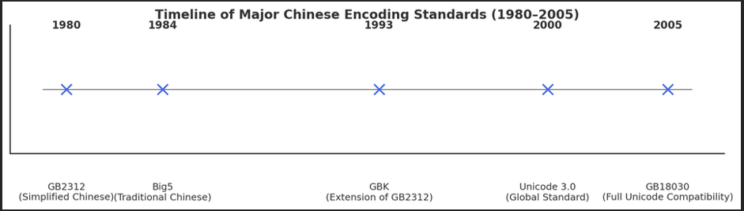

2. Chinese Character Components
Chinese characters are not arbitrary drawings; they are built systematically from smaller, meaningful parts known as components. Each component contributes to the meaning, pronunciation, or overall shape of the character. Understanding these internal structures is essential to both learning Chinese and developing digital systems such as ECC (Easy Chinese Code), which relies on these components for encoding.
In ancient China, characters evolved from pictographs—drawings that represented objects—to complex logograms. Over time, these shapes were standardized into consistent parts known as radicals and phonetic elements, which together help define and categorize characters.
For example, the character “好” (hǎo, good) combines “女” (nǚ, woman) and “子” (zǐ, child). Each part has an independent meaning, but when combined, they create a new word expressing harmony and positivity. This pattern demonstrates the principle of combining smaller semantic and phonetic elements to build complete ideas.
In your ECC dataset, each character is represented using three smaller coded parts (columns 1, 2, and 3). These represent the structural or phonetic sequence of the character, forming a unique code combination that allows efficient character lookup.
The major component categories of Chinese characters include:
- Radicals (部首, bùshǒu): Semantic indicators showing meaning or category (e.g., 木 relates to wood or trees).
- Phonetic components: Provide hints about pronunciation. For instance, in “河” (hé, river), “可” serves as a phonetic clue.
- Compound components: Combine semantic and phonetic features simultaneously.
- Structural components: Define spatial arrangement and maintain visual balance within a character (left-right, top-bottom).
- Single-component characters: Characters that cannot be divided further, such as “一” (one).
- Recurrent components: Frequently appearing parts that convey similar meanings or sounds across multiple characters.
- Pictographic components: The oldest type, representing objects visually (e.g., “山” for mountain, “日” for sun).
These layered structures make Chinese writing logical and analyzable. They also form the foundation of ECC coding, since each ECC code corresponds to a combination of components or sub-elements, making it easier to encode, type, and recall Chinese characters.

2.1 Stroke Type and Stroke Amount
Strokes are the most fundamental units of Chinese writing. Every character, regardless of complexity, is made up of strokes written in a specific order. Strokes determine how components are formed and are crucial for correct handwriting, recognition, and even digital input systems.
Traditional calligraphy and modern digital input methods follow strict stroke order rules to ensure consistency. The ECC system can also rely on stroke sequences as part of its encoding mechanism, linking each code element to specific writing features.
Below are the eight basic stroke types found in Chinese characters:
- Horizontal (横, héng) – a horizontal line from left to right.
- Vertical (竖, shù) – a vertical line from top to bottom.
- Left-Falling (撇, piě) – a diagonal line falling from the top right to the bottom left.
- Right-Falling (捺, nà) – a diagonal line falling from the top left to the bottom right.
- Dot (点, diǎn) – a small dot or short dash, often at the beginning or end of a stroke sequence.
- Rising (提, tí) – a short stroke that rises from the bottom left to the top right.
- Hook (钩, gōu) – a stroke that ends with a small hook, often added to other strokes.
- Bend (折, zhé) – a stroke that changes direction sharply, often combining horizontal and vertical elements.

Figure: Stroke types and amounts
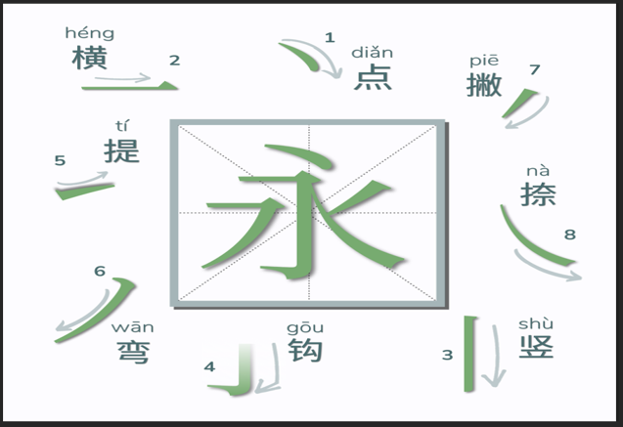

Writing order and stroke structure directly affect readability and recognition. The general writing principles include:
- Top to bottom
- Left to right
- Horizontal before vertical
- Outer before inner
- Center before sides
Each character has a distinct number of strokes depending on its structure and meaning.
For instance:
- “一” (yī, one) – 1 stroke
- “人” (rén, person) – 2 strokes
- “天” (tiān, sky) – 4 strokes
- “明” (míng, bright) – 8 strokes
- “龠” (yuè, flute) – up to 17 strokes
While strokes themselves are not “components,” they are the essential base upon which components and characters are built. A deep understanding of stroke structure improves one’s ability to analyze, memorize, and input characters using systems like ECC. In the context of your project, mastering stroke and component logic helps define precise ECC sequences that correspond to accurate and efficient digital input
2.2 Radicals
Radicals (部首, bùshǒu) are the core building blocks of Chinese characters. They provide clues about a character’s meaning, category, and sometimes pronunciation. A radical can stand alone as a simple character or appear as part of a more complex one. In traditional dictionaries, radicals are used to classify and locate characters efficiently.
In modern input systems like ECC (Easy Chinese Code), radicals serve a similar role in organizing and identifying characters. Each ECC code in the dataset (columns 1, 2, 3) reflects part of a character’s structure—often related to its radical or phonetic pattern—allowing users to find characters quickly through coded sequences.
There are 214 traditional radicals, though modern dictionaries use fewer. Some common examples include:
- 人 (亻, rén) – person → 你 (nǐ), 他 (tā)
- 水 (氵, shuǐ) – water → 河 (hé), 海 (hǎi)
- 木 (mù) – wood → 林 (lín), 森 (sēn)
- 火 (灬, huǒ) – fire → 热 (rè), 烧 (shāo)
- 心 (忄, xīn) – heart → 想 (xiǎng), 怕 (pà)
- 日 (rì) – sun/day → 明 (míng), 晚 (wǎn)
Radicals can appear in different positions within a character—left (你), right (休), top (草), bottom (念), or surrounding (国)—each affecting its structure and meaning. For instance, the radical 氵 often indicates something related to water, while 女 suggests a feminine context.
Recognizing radicals helps learners and systems like ECC break complex characters into smaller, logical parts, improving understanding, search efficiency, and digital encoding
Radical | Meaning | Position | Examples
亻 | Person | Left | 你, 他
氵 | Water | Left | 河, 海
木 | Wood | Base | 林, 村
火 | Fire | Bottom | 热, 灯
忄 | Heart | Left | 想, 恨
日 | Sun | Top | 明, 晴
囗 | Enclosure | Surrounding | 国, 图

3. Relationship Between Chinese Character Components
The structure of Chinese characters is built upon a clear hierarchy — strokes → radicals → components → complete-characters.
Strokes are the smallest writing units, radicals form the semantic or phonetic base, and these elements together create full characters. This relationship defines how Chinese characters convey both meaning and pronunciation.
Each radical consists of one or more strokes arranged in a standard order. For example, 木 (mù, wood) is formed with four strokes — horizontal, vertical, left-falling, and right-falling — and often appears in characters related to trees or nature, such as 林 (lín, forest) and 森 (sēn, woods).
In the ECC (Easy Chinese Code) project, this structure is reflected in the dataset format. Each character is divided into three smaller coded parts (columns 1, 2, 3), representing essential components such as strokes, radicals, or phonetic hints. When a user types an ECC sequence, the system matches it to the correct pattern and displays the corresponding character.
Chinese components interact in several ways:
- Semantic–Phonetic Combination (形声字, xíngshēngzì):
Most characters combine a radical indicating meaning with a phonetic component suggesting pronunciation.
Example: In 河 (hé, river), the radical 氵 (water) shows meaning, while 可 (kě) gives a sound clue.
- Compound Components:
Some characters merge both meaning and pronunciation in one symbol.
Example: 明 (míng, bright) = 日 (sun) + 月 (moon), symbolizing light and clarity.
- Structural Arrangement:
The layout of components follows common patterns such as:
Left–Right (林), Top–Bottom (苗), and Enclosed (国). These patterns keep the character visually balanced and easy to recognize.
Characters differ in complexity depending on their stroke count, which affects readability and categorization.
The general classification is as follows:
Type | Stroke Range | Examples | Description
Simple | 1–5 | 一, 人, 口 | Basic radicals or simple words.
Moderate | 6–10 | 明, 林 | Combine two or more components.
Complex | 11–20 | 樹, 警 | Multiple radicals and added details.
Very Complex | 21+ | 鬱, 鸞 | Rare and intricate characters.

In the ECC system, each ECC code represents this structural logic digitally. Instead of writing strokes manually, users type short code sequences corresponding to radicals or phonetic parts.
This approach connects traditional character construction with modern digital input, allowing faster recognition, accurate matching, and efficient learning.
Radical | Meaning | Strokes | Example Characters
木 | Wood | 4 | 林, 森, 村
水 | Water | 4 | 河, 湖, 海
人 | Person | 2 | 他, 你, 仁
火 | Fire | 4 | 热, 烧, 灯
心 | Heart | 4 | 想, 恨, 怕
日 | Sun | 4 | 明, 晴, 时

Examples of Radicals and Stroke Counts

4. Design of Chinese Input Method (ECCApp)
The ECCApp is a dataset-driven input method designed in Python. It provides a graphical interface using Tkinter where users can type ECC codes to get corresponding Chinese characters. Core libraries include pandas (for reading data.csv) and numpy (for array comparisons). The GUI features include: input field, live prefix suggestions, result display, copy button, and status bar.

Figure: Dataset
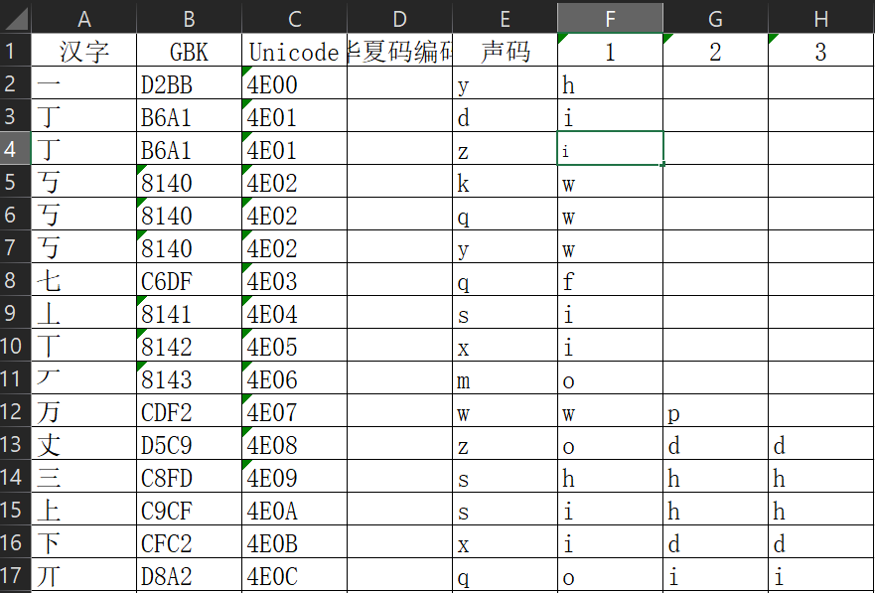

5. Implementation of the Chinese Input Method
When the ECCApp starts, it loads the dataset (data.csv) automatically. The user types a letter sequence representing the ECC code. The core function 'core_return_ecc' processes the input by comparing it with dataset columns (1, 2, 3) to find matches. If a match is found, the corresponding character and voice_code are displayed. The application also shows prefix matches dynamically as the user types.

Feature includes:
- Input validation and status feedback
- Real-time prefix suggestions
- Copy to clipboard and clear input option

Figure : Output for -Real-time prefix suggestions
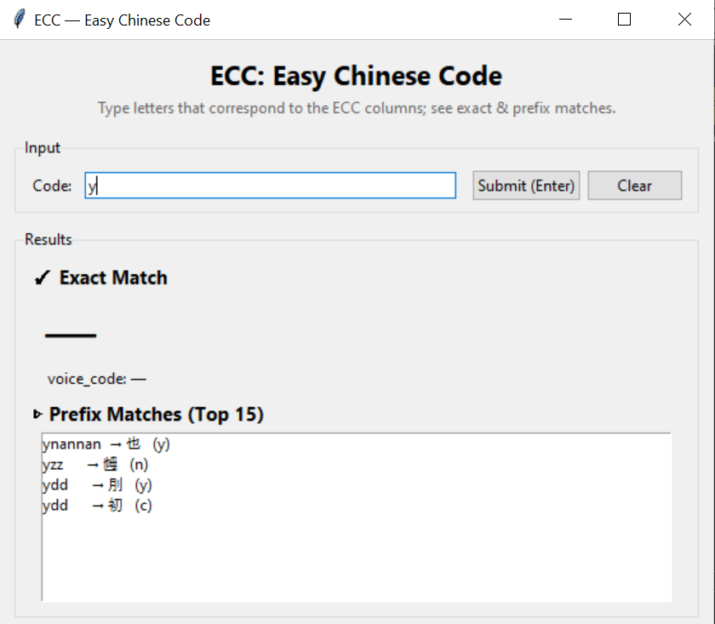

Figure : Exact match output
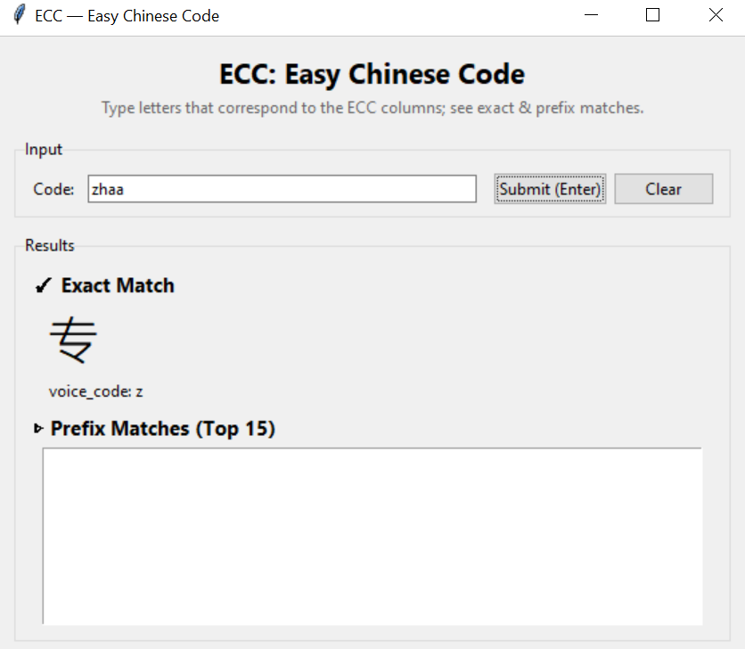
6. Discussion
Compared to similar ECC implementations, this project adds a more responsive graphical interface and live suggestion mechanism. It improves usability by providing clear feedback and easy navigation through results. Limitations include reliance on static dataset structure (fixed three ECC columns) and lack of dataset browsing functionality.
7. Conclusion
The ECCApp successfully implements a working prototype of an ECC-based Chinese character input system. It demonstrates how Python’s GUI and data libraries can simplify the design of language input
tools. The project achieves its goals of interactive input, efficient code matching, and educational visualization of the ECC concept.

